REPORT

Integrated Stress Relief Technology (i-SRT)

Prepared by: |  | Reviewed and Approved by:
Mohd Syahid Abdul Hanan  Inspection Engineer  Date: |  | Mohd Noor Baharin Che Kamarudin  Technical Advisor  Date:

TABLE OF CONTENTS

LIST OF TABLES AND FIGURES 2
1. INTRODUCTION 3
2. OBJECTIVES 3
3. SPECIMEN INFORMATION 3
4. I-SRT TECHNOLOGY 4
5. METHODOLOGY 5
6. RESULT AND DISCUSSION 9
6.1. RESULTS OF PRE-STRESS MEASUREMENT 9
6.2. RESULTS OF POST-STRESS MEASUREMENT 10
7. CONCLUSION 10
ATTACHMENT : 11
RESULTS OF CMMM INSPECTION 11
(COMPARISON CMMM DATA BEFORE AND AFTER ULTRASONIC PEENING TREATMENT) 11

LIST OF TABLES AND FIGURES

Table 1 :Specimen and Equiptment 3
Table 2: List of SCZ on the Specimen 9
Table 3: Differences of Stress Value on the Specimen Before and After Treatment 10

Figure 1: Analyzer TSC-7M-4 and Scanning Device Type 1 4
Figure 2: Hand Tools and Ultrasonic Generator 4
Figure 3: Test Procedures 6
Figure 7: Actual Process of Ultrasonic Peening on Specimen 8
Figure 8: Stress Concentration Zone (SCZ) Location on Specimen 9
Figure 9: Stress Field Gradient of Section 1 12
Figure 10: Stress Field Gradient of Section 2 12
Figure 11: Stress Field Gradient of Section 3 13
Figure 12: Stress Field Gradient of Section 4 13
Figure 13: Stress Field Gradient of Section 5 14
Figure 14: Stress Field Gradient of Section 6 14
Figure 15: Stress Field Gradient of Section 7 15
Figure 16: Stress Field Gradient of Section 8 15
Figure 17: Stress Field Gradient of Section 9 16
Figure 18: Stress Field Gradient of Section 10 16

INTRODUCTION

Residual stress is one of the leading causes of weld joint failure. In most cases, residual stress is detrimental since it can significantly affect engineering properties of materials and structural components, notably fatigue life, distortion, dimensional stability, corrosion resistance, and brittle fracture. Such effects and failure frequently lead to considerable expenditures in repairs and restoration of parts, equipment and structures.

In due to that, a technology known as Integrated Stress Relief Technology (I-SRT) is developed and proposed by MR Technology Sdn. Bhd. to measure and release the residual stress occur in ferrous material. The technology combines Metal Magnetic Memory (MMM) technology for residual stress measurement on ferrous metal and Ultrasonic Peening Technology (UP) for high frequency stress relieve method. MMM will assess the residual stress experienced by the ferrous metal due to fabrication or in-service condition. A field-test has been conducted by MR Technology Sdn Bhd in collaboration with MPI Solutions to evaluate the capability of integration between MMM and Ultrasonic Peening technology. This report is prepared strictly for both parties involves in the field-test which were conducted in Le-Locle, Switzerland.

OBJECTIVES
The objectives of this field-test are:
- To measure residual stress using Metal Magnetic Memory in accordance ISO 24497:2007 (Non-Destructive testing – Metal Magnetic Memory).
- To reduce the residual stress on ferrous material using high frequency treatment method.
- To measure the residual stress on the treated area using MMM technology.
- To evaluate the capability of integration between MMM and Ultrasonic Peening technology as the main technology in I-SRT.

SPECIMEN INFORMATION

Table 1 shows specimen and equipment details used throughout the test.

Table 1 :Specimen and Equiptment
Specimen | Material | Carbon Steel Plate (Welded)
 | Thickness | 10mm
Equipment (1) | Contact Metal Magnetic Memory | Analyzer TSC-7M-4
 |  | Scanning Device – Type 1
Equipment (2) | Ultrasonic Peening | Hand Tool – with piezoelectric transducer
 |  | Ultrasonic Generator

I-SRT TECHNOLOGY

The ideas of I-SRT programme is designed by MR Technology Sdn Bhd in collaboration with MPI Solution is to fulfil the industrial needs in providing assurance on the impact of stress in the material. The integration of both technology is believed could be used as a complete solution with measurement and treatment of the inspection object.

Metal Magnetic Memory (MMM)
Metal Magnetic Memory (MMM) technology is utilised as measurement tools for residual stress on ferrous material. The technology is direct-contact with inspection object in obtaining the position and actual stress condition based on emission of natural magnetic field distribution of the inspection object. MMM is an ISO 24497:2007 recognised inspection technology, which has been increasingly utilised in most part of the world.
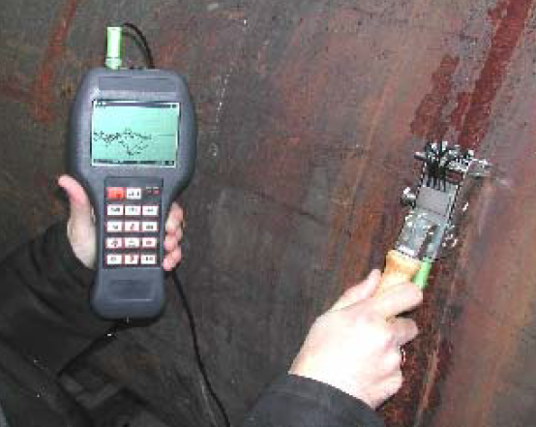
Figure 1: Analyzer TSC-7M-4 and Scanning Device Type 1

Ultrasonic Peening
Ultrasonic Peening is a technology that utilises ultrasonic from piezoelectric sensor in generating harmonic resonance for the specifically designed pin/impact hammer. The harmonic resonance through designed pin will result in Compressive Residual Stress, Stress Relief, and Grain Structure improvements. The technology itself has been recognised in American Bureau of Shipping (ABS) , International Institute of Welding (IIW), ASTM as high frequency treatment for stress relief technology.
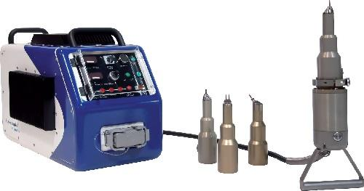
Figure 2: Hand Tools and Ultrasonic Generator

METHODOLOGY

There are four (4) stages to the test; to measure residual stress on specimen, to determine the distribution of residual stresses by analysing the potential areas with stress concentration zones on specimen by using Contact Metal Magnetic Memory Inspection Method (CMMM) before and after Ultrasonic Peening treatment.

Figure 3 shows the steps of the test procedures.

Figure 3: Test Procedures

Stage I: Pre-Stress Measurement
Pre-stress measurement represents the measurement of inspection object before any treatment conducted on the samples. During this stage, procedures such as specimen measurement, scheme marking and visual inspection were also carried out.

Sample Marking
Figure 4 show the inspection scheme to measure stress on the specimen which divided into 10 sections. Figure 6 show the area of Stress Concentration Zone (SCZ) determined. Width for each section were separated into 30mm. Section 1 until 9 represent the parent metal area while Section 10 represent the welded joint area.

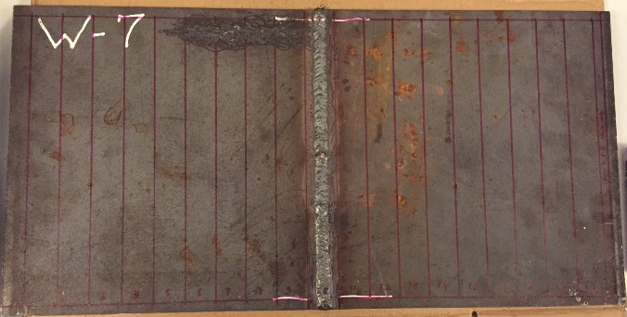
A-Side
Figure 4: CMMM Inspection Scheme

Figure 5 show the typical inspection scheme for CMMM Inspection on the on the sample. 4 ferro-probes will cover for each section. Measurement for each section is conducted parallel with the direction of the welded joint.

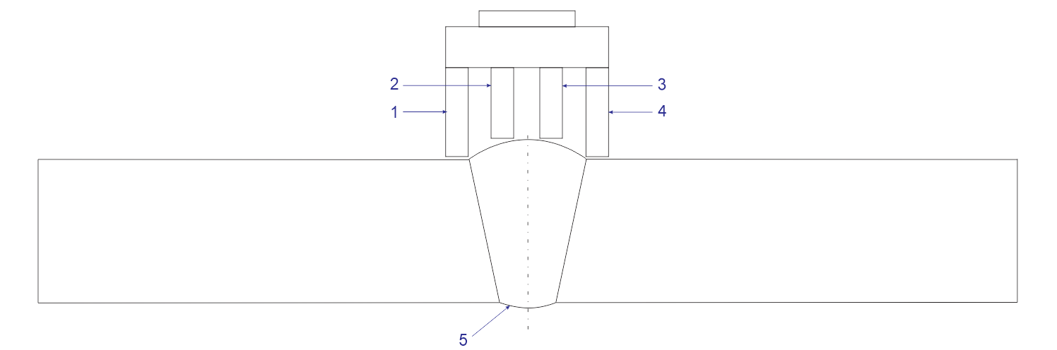
Figure 5: Scheme of CMMM Inspection on Weld Joint
1 – Flux Gate Sensor No 1; 2 – Flux Gate Sensor No. 2; 3 – Flux Gate Sensor No. 3; 4 – Flux Gate Sensor No. 4; and 5 – Weld Joint
Stage II: Ultrasonic Peening Treatment
Ultrasonic Peening treatment was performed on the Stress Concentration Zone (SCZ) only which represent the residual stress area found on the specimen. Figure 7 show the actual process of Ultrasonic Peening on specimen. For this field-test, the ultrasonic peening was conducted only one time for the SCZs area.

Figure 7: Actual Process of Ultrasonic Peening on Specimen
Stage III: Post-Stress Measurement
Post-stress measurement involves with the measurement after the ultrasonic peening treatment. MMM inspection is performed with the same inspection scheme at the area which were treated by ultrasonic peening. Stage III is a crucial stage as it represent the capability for both technology in measuring and treatment on the stress condition on ferrous material.

Stage IV: Report Preparation
Report is prepared accordingly for proper data documentation and for future reference.

RESULT AND DISCUSSION

RESULTS OF PRE-STRESS MEASUREMENT
From the measurement of 10 locations, there’s a number of SCZs findings found. However, more localised SCZs were at Section 5 until 10 which covers approximately 150mm width and 45mm in length. Each SCZs findings for each section were marked in blue dotted box in the attachment graph.
For this field-test, the ultrasonic peening treatment were conducted on the Section 5 until Section 10 only (as shown in Figure 8 below). From the pre-stress measurement using MMM, it shows the whole localised SCZs has a maximum field gradient by length dH/dx of 54.06 A/m/mm (SCZ-4) which is obtained in Table 2 below. Furthermore, Table 2 below represent the maximum SCZs findings located in the same area for the whole 5 section.

A-Side
Figure 8: Stress Concentration Zone (SCZ) Location on Specimen

Table 2: List of SCZ on the Specimen
No | SCZ No | Section | Start Point of SCZ, mm | End Point of SCZ, mm | Length of SCZ, mm | Max dH/dx  (A/m/mm)
1 | SCZ-1 | 5 | 244.38 | 280.00 | 35.62 | 14.07
2 | SCZ-2 | 6 | 234.08 | 280.00 | 45.92 | 29.36
3 | SCZ-3 | 7 | 240.85 | 280.00 | 39.18 | 52.98
4 | SCZ-4 | 8 | 240.28 | 280.00 | 36.89 | 54.06
5 | SCZ-5 | 9 | 243.11 | 280.00 | 36.89 | 37.76
6 | SCZ-6 | 10 | 270.40 | 280.00 | 9.60 | 13.69

The Ultrasonic Peening has been applied on the marked Stress Concentration Zone (SCZ) area (as shown in Figure 8 above). Once completed, Post-Stress Measurement using MMM method is used to inspect section 5 to section 10 to monitor and analyse the differences of the stress distribution at the Ultrasonic Peening treatment area.

RESULTS OF POST-STRESS MEASUREMENT
Based on the assessment during post-stress measurement, it shows that whole of treated area has a significant reduction in terms of maximum stress value with the range of 55 till 87% for each section (as shown in Table 3 below). The reduction is based on one-time ultrasonic peening treatment.

Table 3: Differences of Stress Value on the Specimen Before and After Treatment
No | SCZ No | Section | Max dH/dx (A/m/mm) | Max dH/dx (A/m/mm) | Percentage of Reduction, (%)
 |  |  | Before UP Treatment | After UP Treatment
1 | SCZ-1 | 5 | 14.07 | 6.27 | 55.44
2 | SCZ-2 | 6 | 29.36 | 7.47 | 74.56
3 | SCZ-3 | 7 | 52.98 | 6.95 | 86.88
4 | SCZ-4 | 8 | 54.06 | 9.09 | 83.19
5 | SCZ-5 | 9 | 37.76 | 8.09 | 78.58
6 | SCZ-6 | 10 | 13.69 | 4.11 | 69.98

CONCLUSION

Based on whole assessment, I-SRT could provide:

- Ultrasonic peening treatment can redistribute and minimizing stress concentration at the treated area of the specimen.
- By using Contact Metal Magnetic Memory (CMMM) method to measure stress on specimen, it is clearly show the reduction of stress after specimen going through Ultrasonic Peening treatment.
- The efficiency of Ultrasonic Peening to reduce residual tensile stress is up to 86.88%.
- Stress gradient is significantly minimized at the whole section of the specimen due to redistribution of the stress concentration even though Ultrasonic Peening treatment were conducted localised at the marked area.

I-SRT shows a significant result in measuring and treating the residual stress on ferrous material. This is shown based on the residual stress measurement during pre and post-stress measurement. Based on the field-test combination for two technologies in I-SRT can lead to newly developed concept of total solution in the stress measurement and treatment for ferrous material whereby:

- MMM can be used as the best tool in providing assurance of stress measurement for ferrous material.
- Ultrasonic Peening treatment can be used to release the stress.

ATTACHMENT :

RESULTS OF CMMM INSPECTION

(COMPARISON CMMM DATA BEFORE AND AFTER ULTRASONIC PEENING TREATMENT)

AFTER
BEFORE
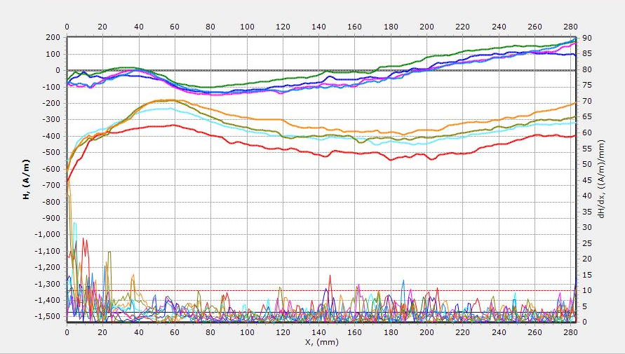 | No CMMM data on this section due to no significant Stress Concentration Zone
Figure 9: Stress Field Gradient of Section 1
AFTER
BEFORE
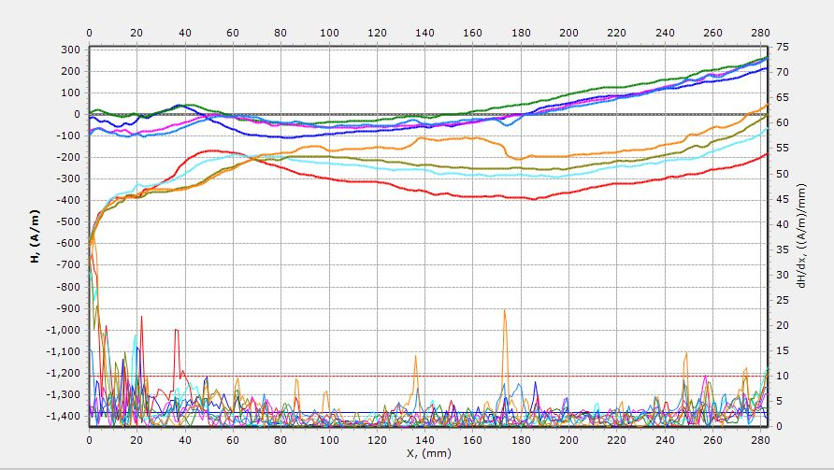 | No CMMM data on this section due to no significant Stress Concentration Zone
Figure 10: Stress Field Gradient of Section 2
BEFORE
AFTER
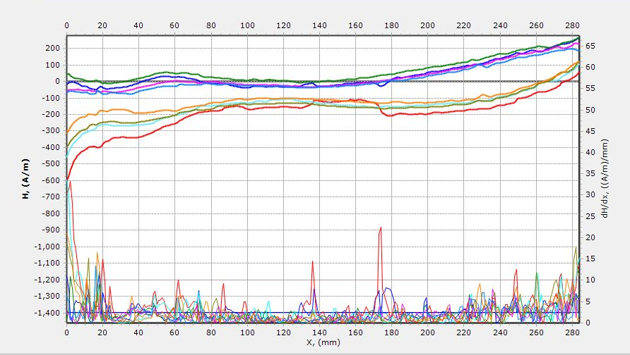 | No CMMM data on this section due to no significant Stress Concentration Zone
Figure 11: Stress Field Gradient of Section 3
AFTER
BEFORE
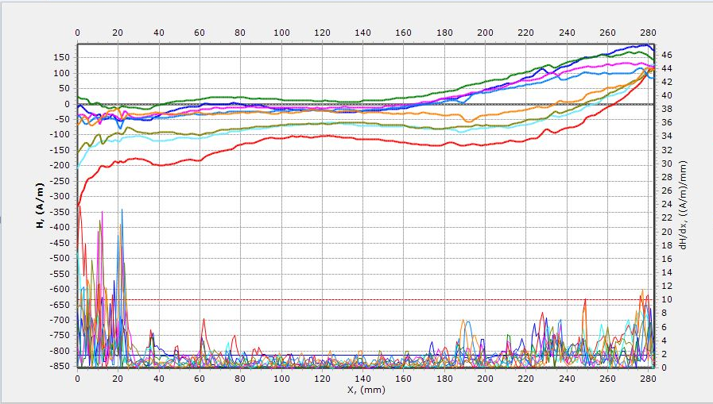 | No CMMM data on this section due to no significant Stress Concentration Zone
Figure 12: Stress Field Gradient of Section 4
BEFORE
AFTER
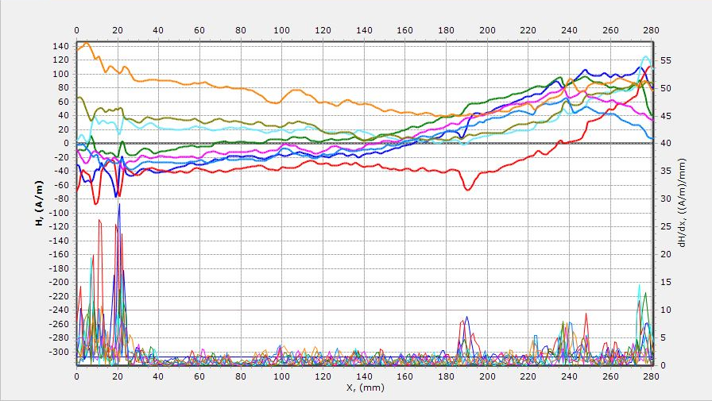  14.07  SCZ 1  z | 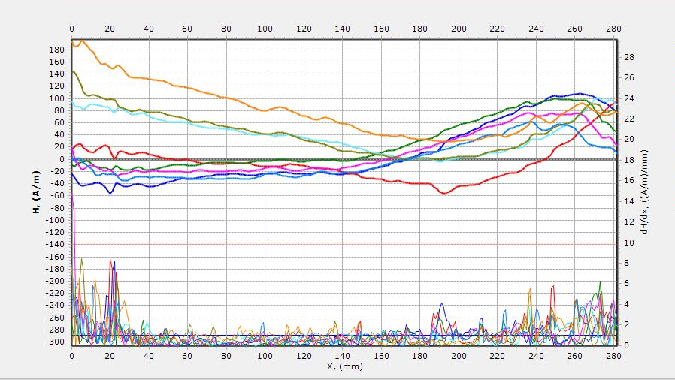  6.27
Figure 13: Stress Field Gradient of Section 5
BEFORE
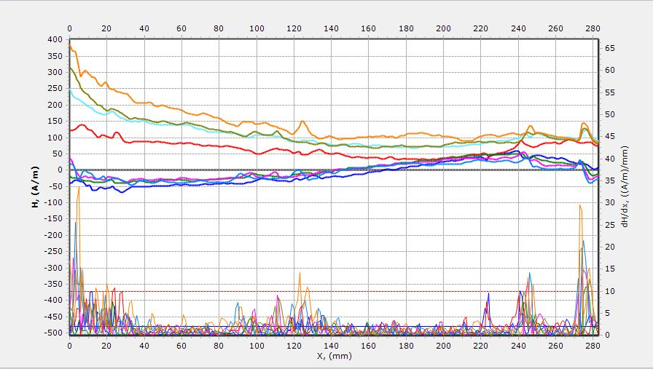  29.36  SCZ 2 | 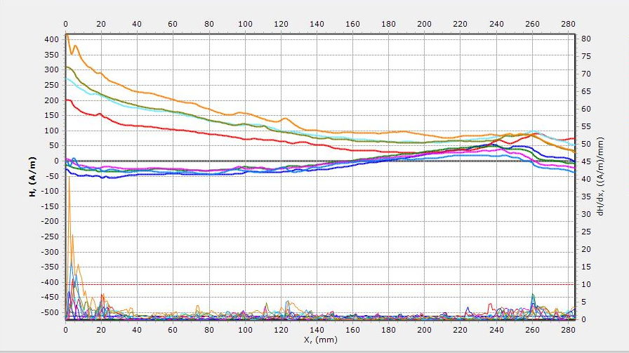  7.47  AFTER
Figure 14: Stress Field Gradient of Section 6
BEFORE
AFTER
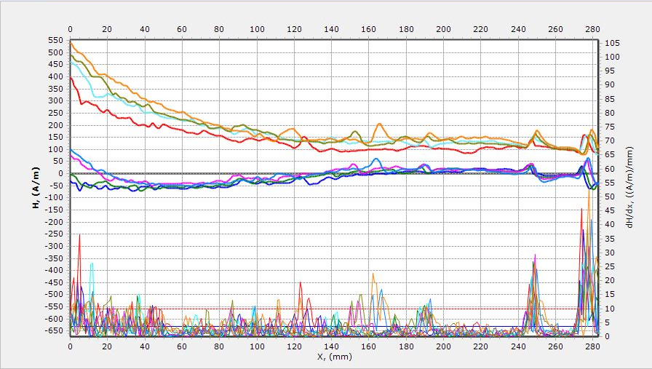  52.98  SCZ 3 | 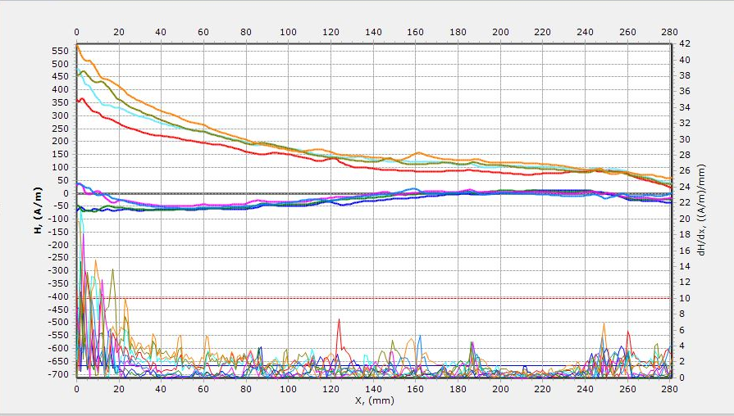  6.95
Figure 15: Stress Field Gradient of Section 7
BEFORE
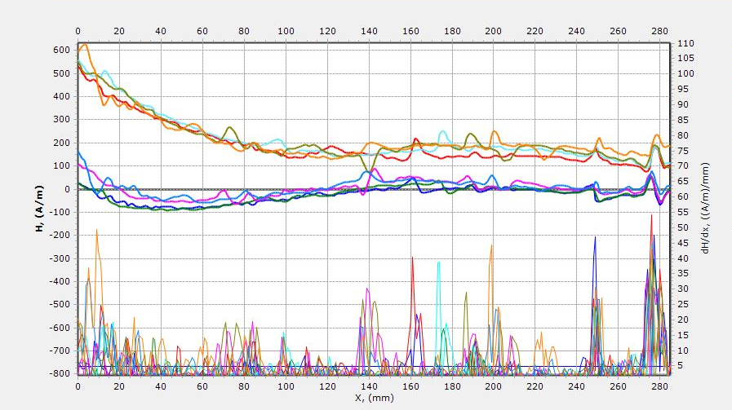  54.06  SCZ 4 | 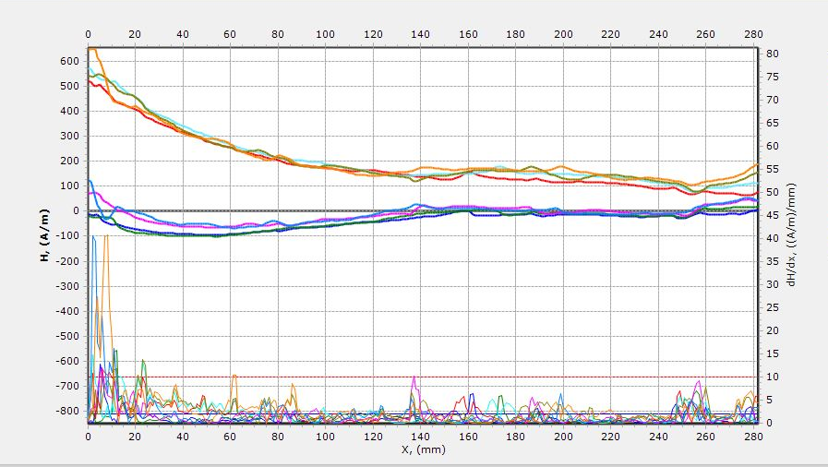  9.09  AFTER
Figure 16: Stress Field Gradient of Section 8
BEFORE
AFTER
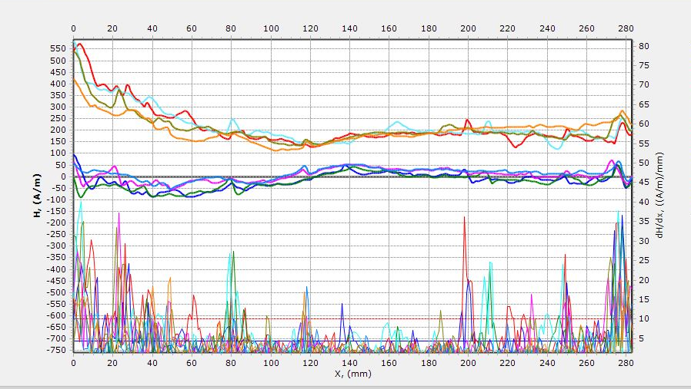  37.76  SCZ 5 | 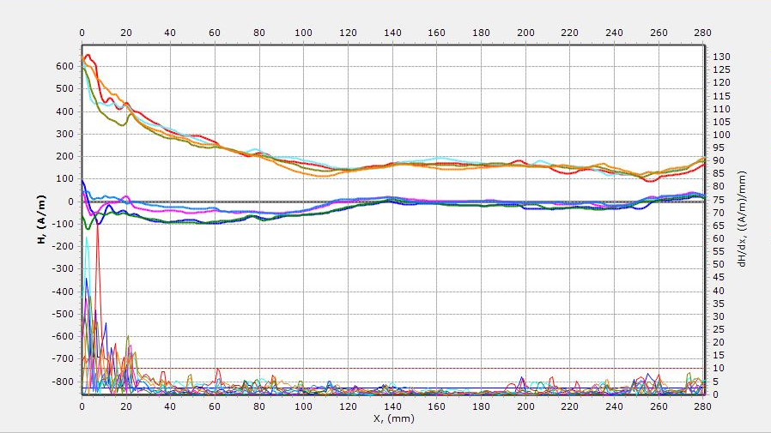  8.09
Figure 17: Stress Field Gradient of Section 9
BEFORE
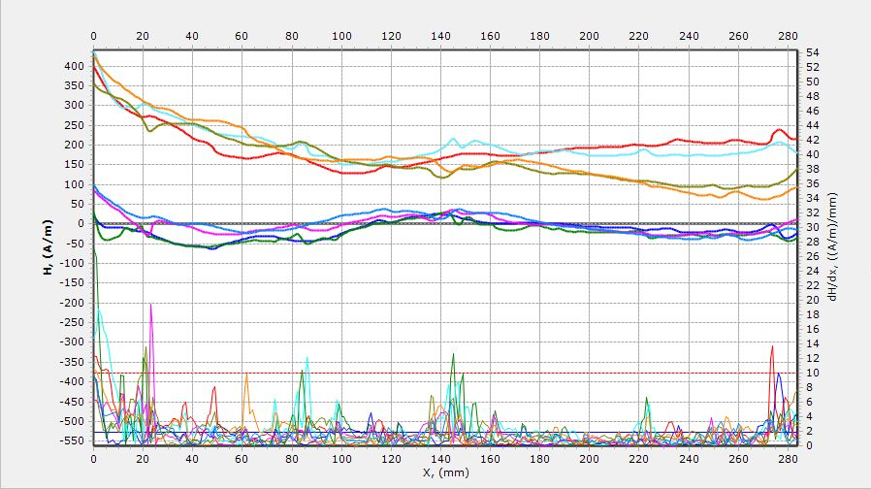  v  v  v  13.69  SCZ 6 | 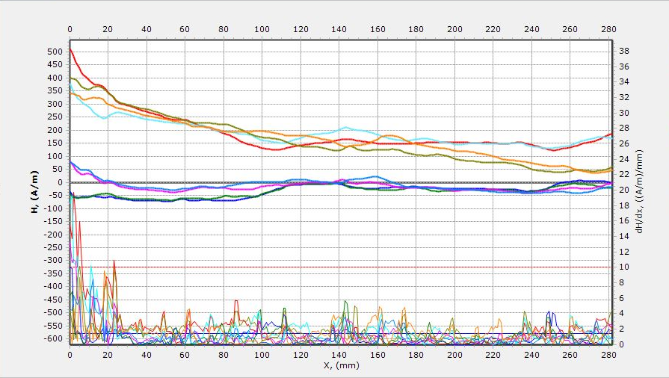  v  v  v  4.11  AFTER
Figure 18: Stress Field Gradient of Section 10

